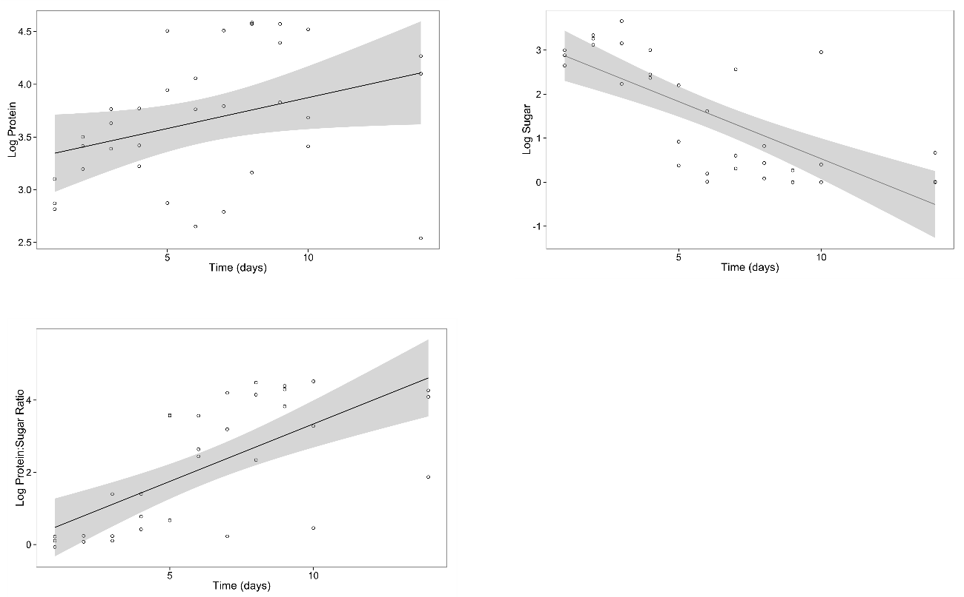
Figure S1 – The macronutrient composition of strawberries changes with the stage of decay. The plots show the log transformations of protein (top left) and sugar (sucrose and glucose) amounts in ug per μl (top right) and protein to sugar ratio (bottom left) over the course of 14 days in rotting strawberries for three replicates. Black lines indicate the regression estimates from linear models and the grey shaded areas represent 95% confidence intervals.

