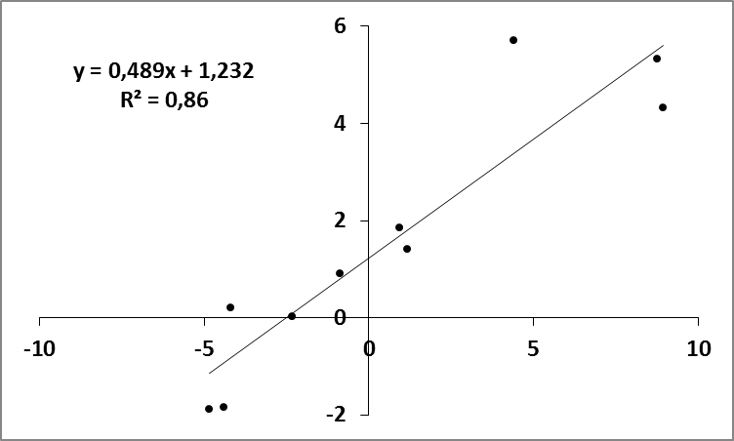
HS/C or WDS/C in the microarray
HS/C or WDS/C in RT-qPCR (log₂ expression ratio)

Supplementary Fig. S2. Comparison of gene expression ratios obtained by microarray and by RT-qPCR. Expression profiles are shown for randomly chosen transcripts whose expression was significantly up- or down- regulated in the microarray analysis in HS and in WDS. The microarray fold change are plotted on the X-axis against the log₂ (expression ratio) values obtained by RT-qPCR on the Y-axis.

Procedure:
Total RNA was extracted as described in Materials and Methods. Nucleic acid concentration of each sample was quantified by spectrophotometry using the software Gen5 1.09 (Synergy HT, Bio-Tek Instruments, Winooski, USA). Total RNA quality was assessed using the A₂₆₀/A₂₈₀ and A₂₆₀/A₂₃₀. Only RNA samples with A₂₆₀/A₂₈₀ between 1.8 and 2.1 and A₂₆₀/A₂₃₀ between 2.0 and 2.2 were used. Total RNA integrity was checked through 1% agarose gel electrophoresis under denaturing conditions. RNA samples were treated with RQ1 RNase-Free DNase (Promega, Madison, WI). cDNA was synthesized from 2µg of total RNA using oligo(dT)₂₀ in a 20 µL-reaction volume using RevertAid Reverse Transcriptase (Fermentas Life Science, Helsingborg, Sweden) according to the manufacturer’s recommendations.
Primer pairs were designed for Act2, L2 and eight probe sets (VVTU27646_s_at, VVTU3450_at, VVTU16209_at, VVTU13941_at, VVTU3801_s_at, VVTU27205_s_at; VVTU27617_s_at and VVTU5985_s_at; probeset annotation in Additional file 2 and 3), as in Coito et al [1]. RT-qPCR was performed in 96 well white reaction plates (Bio-Rad, Hercules, CA), using an IQ5 Real Time PCR (Bio-Rad, Hercules, CA) with three biological replicates and two technical replicates. The 20 µL reaction mixture was composed of 1 µL cDNA diluted 50-fold, 0.5 µM of each gene-specific primer and 10 µL master mix (SsoFast_EvaGreen Supermix, Bio-Rad, Hercules, CA). Amplification of PCR products was monitored via intercalation of Eva-Green (included in the master mix). The following program was applied: initial polymerase activation, 95 ºC, 3 min; then 40 cycles at 94 ºC 10 s (denaturation), 60 ºC 20 s (annealing), 72 ºC 15 s (extension). The PCR products were run on 2% agarose gels to make sure that there was only one amplicon of the expected size. PCRs with each primer pair were also performed on samples lacking cDNA template, in triplicate (no template controls).
To assess amplification efficiency of the genes, identical volumes of cDNA samples were diluted and used to generate five-point standard curves based on a five-fold dilution series (1;1:5;1:25;1:125;1:625), in triplicate. Amplification efficiency (E) is calculated as E= 10^{(-1/a)}-1, “a” being the slope of the linear regression curve (y = a log(x) + b) fitted over the log-transformed data of the input cDNA dilution (y) plotted against the respective quantification cycle (Cq) values (x). E-values of the target genes were considered comparable when they did not exceed 100 ± 10%, corresponding to a standard curve slope of 3.3 ± 0.33. All cDNA samples were diluted 50 fold and were amplified in duplicate in two independent PCR runs.
To generate a baseline-subtracted plot of the logarithmic increase in fluorescence signal (ΔRn) versus cycle number, baseline data were collected between the cycles 5 and 17. All amplification plots were analysed with an R_{n} threshold of 0.2, at the beginning of the region of exponential amplification, to obtain Cq (quantification cycle) and the data obtained were exported into a MS Excel workbook (Microsoft Inc.) for further analysis. In order to compare data from different PCR runs or cDNA samples, several housekeeping genes were tested using geNorm [2] and in the end, C_{q} values were normalized to the C_{q} values of Act2 and L2.

1. Coito JL, Rocheta M, Carvalho LC, Amâncio S: Microarray-based uncovering reference genes for quantitative real time PCR in grapevine under abiotic stress. BMC Research Notes 2012, 5:220.
2. Vandesompele J, Preter KD, Pattin F, Poppe B, Roy NV, Paepe AD, Speleman F: Accurate normalization of real-time quantitative RT-PCR data by geometric averaging of multiple internal control genes Genome Biol 2002, 3:1-12.

